Title Page:
Performance Analysis of Response Time in Medication-Reminder for A Comparative Study between Android Application and iOS Application
Nisha. N1, Dr T Suresh Balakrishnan2
Nisha N¹
Research Scholar,
Department of Computer Science Engineering,
Saveetha School of Engineering,
Saveetha Institute of Medical and Technical Sciences,
Saveetha University, Chennai, Tamil Nadu, India. Pin code: 602105
192011495L.sse@saveetha.com

Dr T Suresh Balakrishnan²
Project Guide, Corresponding Author
Department of Computer Science Engineering,
Saveetha School of Engineering,
Saveetha Institute of Medical and Technical Sciences,
Saveetha University, Chennai, Tamil Nadu, India. Pin code: 602105
sureshbalakrishnant.sse@saveetha.com

Keywords: iOS Application, Android Application, Response time, Medication-Reminder, Research, Treatment
ABSTRACT:
Aim: This project aims to assess and contrast the navigation response times and user navigation durations experienced during the treatment process on both the Medication-Reminder Android application and the iOS platform. Materials and Methods: To improve the assessment of response times in treatment processes, an Android application (N=10) and an iOS application (N=10) will be utilized for text summarization. Gpower analysis will be employed with 80% power to determine the appropriate sample size. Result: The Android application exhibits a response time of 34.58 milliseconds in the evaluation of treatment, while the iOS application demonstrates superior performance with a response time of 29.33 milliseconds. Statistical analysis indicates a significant difference between the Android and iOS platforms, as indicated by a p-value of 0.007 (p < 0.05). Conclusion: The iOS application showcases a response time of 29.33 milliseconds, while the Android application displays a response time of 34.58 milliseconds.
Keywords: iOS Application, Android Application, Response time, Medication-Reminder, Research, Treatment

INTRODUCTION:
This study conducts a quantitative analysis of the time required to navigate between the Medication-Reminder iOS and Android applications during the treatment process (Ahmed et al. 2018). Utilizing robust metrics, the study identifies differences in user experiences and performance between the two systems (Al-Arkee et al. 2021). These findings offer developers opportunities to iteratively enhance interfaces, thereby increasing user satisfaction (Huang et al. 2019). Through the use of a medication reminder, organizations can make well-informed decisions regarding treatment-related activities, ensuring maximum participation (Morawski et al. 2018). Ultimately, our study contributes valuable insights to the broader discourse on digital user experience, aiding in the improvement of online application design to facilitate seamless interaction with medical platforms (Ng, Carter, and El-Den 2019).
In the extensive field of medication reminder research, a wealth of scholarly works is available through reputable platforms such as the IEEE Xplore digital repository, which offers access to (1,258 journals). Furthermore, the Science Direct website provides access to a substantial collection of (178,590 articles), and the Google Scholar database hosts a vast repository of (3,270,000 articles). Additionally, Springer Publishers contribute to the abundance of available literature with (8,290 articles). In this paper, we delve into a thorough examination of the performance metrics related to response time in the medication reminder application (Santo et al. 2019). By meticulously analyzing the time taken for various actions and processes within the app, including loading screens, accessing features, and executing commands, we aim to provide a comprehensive overview of its responsiveness (Pérez-Jover et al. 2019). Additionally, we seek to identify potential bottlenecks or inefficiencies that may hinder user experience and productivity (Peng et al. 2020). Through detailed performance analysis, we aspire to offer actionable recommendations for optimizing the Medication-Reminder application to ensure seamless functionality and improved user satisfaction. Moreover, this study will contribute valuable insights to the broader discourse on mobile application performance evaluation, with implications for enhancing the usability and effectiveness of orthopedic assistance tools like Medication-Reminder (Habib et al. 2021). Understanding the importance of timely response in orthopedic support applications, we embark on a systematic investigation to assess the efficiency of the Medication-Reminder platform (Contreras et al. 2019). Ultimately, our findings will inform developers and stakeholders about areas for improvement and optimization to enhance user experience and satisfaction. By fostering a deeper understanding of response time dynamics, this study contributes to advancing the field of mobile health technology and orthopedic care.
Examining the effectiveness of online applications is crucial within the realm of technology-driven philanthropy, ensuring smooth and convenient contribution procedures. This study delves into the comparison of navigation response times between the Medication-Reminder iOS platform and its Android counterpart throughout the contribution process (Abu-El-Noor et al. 2020). By exploring the nuanced aspects of digital philanthropy, the research aims to shed light on user engagement dynamics specific to treatment transactions, addressing a significant gap in the existing literature (Ahmed et al. 2018). With a multidisciplinary research team comprising specialists in usability, philanthropy, and human-computer interaction, the study is poised to provide comprehensive insights (Park et al. 2019). The ultimate goal is to optimize user experiences in the digital treatment context by furnishing empirical data on the functionality of the Medication-Reminder Android application and iOS platform during the treatment process.
Materials & Methods:
This study is based at the Ideation Laboratory, located within the Computer Science and Engineering department of the Saveetha School of Engineering, which is part of the broader Saveetha Institute of Medical and Technical Sciences. The research is structured around the perspectives of two distinct groups: Group 1 focuses on exploring the intricacies of the Android application, while Group 2 delves into the realm of the iOS application (Wiecek et al. 2020). Employing a robust method, the study sets the G-power at a strong 80% and utilizes the Clincalc Website's analytical power to estimate the optimal iteration sample size. Through meticulous calculation, the study determines a sensible number of iterations, set at 10 for each group, resulting in a total sample size of 20 (Islam et al. 2022).
XAMPP is a software program designed to streamline the process of setting up a local web server environment on a PC, making it both simple and quick. Its purpose is to simplify the creation and configuration of essential Android development components, allowing users to install and operate a functional web server on their own PCs. The acronym "XAMPP" represents its constituent parts: Apache, MariaDB (formerly MySQL), PHP, and Perl. Primarily, XAMPP is used to facilitate the development and testing of websites and Android applications in a controlled, local environment before they are deployed to a live server. With XAMPP, the need for users to install and manage individual components such as web servers, database servers, and programming languages is eliminated. Developers can swiftly establish a local server environment with XAMPP that closely mirrors the setup of a production server. This local server configuration is essential for testing the functionality and interoperability of Android applications without requiring an internet connection. XAMPP is particularly beneficial for developers who work with PHP and MySQL, as these components are included in the XAMPP package. As a reliable and user-friendly solution, XAMPP simplifies the process of setting up a local web server, enabling developers to focus more time and effort on building and refining their Android projects in a secure environment on their personal computers. Overall, XAMPP serves as a valuable tool for Android developers by providing a convenient and efficient means of setting up a local server for Android development and testing.
The iOS application's architecture incorporates a specialized API that facilitates seamless connectivity to the XAMPP server. Utilizing the Swift programming language, the application effectively coordinates and accesses this API. Typically, HTTP GET requests are utilized to interact with specific API endpoints, triggering corresponding PHP scripts on the server. These PHP scripts serve as API handlers, retrieving relevant data from the database and encapsulating it in the widely used JSON format before transmitting it back to the iOS application. This systematic approach enhances the efficiency and effectiveness of data transfer between the application and the server. The deliberate integration of PHP code within the Android application dictates how the connection to the XAMPP server is established. PHP scripts are pivotal in establishing a connection to the MySQL database on the XAMPP server. They simplify the process of accessing and modifying data stored in the database by executing SQL queries within this connection architecture. This intricate procedure ensures seamless interaction between the Android application and the MySQL database hosted on the XAMPP server. PHP scripts serve as versatile intermediaries, facilitating communication with the database through SQL queries to address the evolving data requirements of the Android application.
iOS application
The objective of this project is to enhance the system to deliver a more seamless and responsive user experience. The iOS application serves as a reference for preparation group 1, focusing on addressing navigation delays and response times during the treatment and medical request processes within the Medication-Reminder iOS application. The aim is to mitigate delays and ensure timely communication through strategic enhancements and refined procedures, thereby enhancing the overall efficiency of the application for treatment within the dynamic medication reminder environment. Table 1 delves into the details, presenting the pseudocode of the iOS Application and encapsulating the central processing unit.

Android application
To provide consumers with a more enhanced and responsive experience, our focus is on improving the system architecture. The Android application serves as a sample preparation group 2, targeting issues related to response time and navigation latency during the treatment procedures within the Medication-Reminder Android application. This involves optimizing data, making server-side modifications, and implementing efficient algorithms. Through careful adjustments of these parameters, we aim to minimize latency and enhance real-time updates, facilitating smooth and enjoyable user interaction with the program. Moreover, by incorporating user input and iterative testing, essential elements of the continuous development process, we can tailor the speed of the Android application to meet the evolving demands of medication reminder enthusiasts. Table 2 presents the pseudocode for the Android Application.
Statistical Analysis
IBM SPSS is widely regarded as a practical research tool for categorizing statistical data across various industrial domains. It offers a range of commonly used computations, including mean, F-value, degrees of freedom (df), and standard error, which are essential for determining significance. The primary objectives of utilizing SPSS include computing response times and extracting resource allocation data from the dataset (Shrivastava et al. 2021). These analyses are crucial for understanding and addressing delays in the Medication-Reminder application's response time during real-time navigation in treatment procedures.
RESULTS
Table. 1 symbolizes the essential procedures for initiating an API request, resolving any issues encountered, interpreting the response, and calculating the response time of the iOS and Android applications.
Table. 2 consists of the PHP script for user authentication and encompasses key processes such as initiating a session, establishing a database connection, retrieving user input, executing SQL queries, validating authentication, computing response times, and logging for both iOS and Android applications.
Table. 3 indicates that text data has been submitted and the sample size is N = 10. Response time rates for developing iOS and Android apps are calculated every ten iterations. In terms of accuracy, the iOS application outperforms the Android application.
Table. 4 compares data for independent samples using the Android Development Algorithm and iOS. The average response time for Android development is 34.58, whereas for iOS development, it is 29.33. The relative standard deviations for iOS and Android development are 4.053 and 4.582, respectively. Android Development has a standard error mean of 1.323, while iOS has a mean of 1.170.
Table. 5 shows the confidence interval of 95% is utilized to compare iOS with the Android Development Algorithm in statistically independent samples, employing a T-Test. The findings indicate a statistically significant difference between the Android Development and iOS algorithms, with a p-value of 0.007 (p<0.05).
Fig. 1 displays the patient list screen of the Medication-Reminder application from the doctor login where the doctor can view all the patients. From this screen, the doctor can see the patient’s name, ID, profile, and age. By tapping on the particular patient details he can access all the details of the patient such as personal details, points, health status, etc.
Fig. 2 displays the comparison reveals that the mean response time for the iOS algorithm is 29.33, whereas for the Android Development method, it is 34.58. The Y-axis represents the mean response time, while the X-axis depicts the comparison between iOS and Android Development approaches. An error bar of ±2 standard deviations.
Fig. 3 displays the database tables of the Medication-Reminder application that are used to store data such as doctor details, patient details, tasks, points, videos, task assignments, patient’s health status, etc. This data segregation helps us to understand the procedure of the application easily.

DISCUSSION
The significance value is determined using the findings of an independent sample T-test analysis. Overall, the iOS application exhibits a faster performance by 29.33 milliseconds compared to the Android application, which operates 34.58 milliseconds slower. The significance level is calculated to be 0.007, which is smaller than 0.05.
This study investigates the crucial relationship between doctors and patients by examining response times in treatment procedures using iOS and Android Applications. It underscores the significance of timely responses and explores how real-time monitoring provided by Android and iOS platforms enhances the overall user experience (Park et al. 2019). The study underscores the importance of technological solutions, such as efficient algorithms and data optimization, in overcoming navigation delays and optimizing system architecture (Curtis et al. 2019). Additionally, it elucidates how the Medication-Reminder framework's continuous testing and user feedback are iterative processes (Curtis et al. 2019). Discussions in this research predominantly focus on enhancing response times over time, improving user interfaces, and strategically leveraging technology to enhance the effectiveness of Medication-Reminder's treatment procedures (Kosse et al. 2019). The research highlights the iterative nature of the Medication-Reminder platform's user feedback process, emphasizing ongoing testing and improvement to better align with user experiences and preferences (Limmroth et al. 2019). This iterative approach not only underscores the platform's adaptability to user demands but also serves as a deliberate strategy to maximize Medication-Reminder's overall effectiveness (Manigault et al. 2020).
The success of the project relies on several critical components working harmoniously to advance its objectives. Adequate financial, human, and technological resources are imperative for the project's advancement. Clearly defined targets and timelines, coupled with effective planning and execution, are crucial for steering the project towards its desired outcomes. Involving actively and fostering open communication helps establish a shared understanding and commitment to the project's goals. Efficient risk management strategies, such as identifying and addressing any obstacles, are necessary for achieving objectives. Selecting and applying the appropriate technology and tools are key to the success of the most efficient projects. Projects with legal implications must adhere to all relevant laws and regulations. The competence and collaborative efforts of the project team also contribute significantly to overall success.

CONCLUSION

During our evaluation of the Medication-Reminder Android Application and iOS, focusing on treatment procedures, we observed that the Android application exhibited a slower navigation response time compared to the iOS application. Our analysis, utilizing a resource allocation dataset, revealed a significant disparity in response times between the two platforms. Notably, the iOS application demonstrated impressive performance in estimating network demand, achieving a response time of just 29.33 milliseconds, whereas the Android application required 34.58 milliseconds. Interestingly, our survey suggests that an iOS application is more effective in displaying results compared to the Android app. The computed p-value of 0.007 indicates statistical significance (p<0.05) in the comparison.

REFERENCES
Abu-El-Noor, Nasser Ibrahim, Yousef Ibrahim Aljeesh, Bettina Bottcher, and Mysoon Khalil Abu-El-Noor. 2020. “Impact of a Mobile Phone App on Adherence to Treatment Regimens among Hypertensive Patients: A Randomised Clinical Trial Study.” European Journal of Cardiovascular Nursing: Journal of the Working Group on Cardiovascular Nursing of the European Society of Cardiology 20 (5): 428–35.
Ahmed, Imran, Niall Safir Ahmad, Shahnaz Ali, Shair Ali, Anju George, Hiba Saleem Danish, Encarl Uppal, et al. 2018. “Medication Adherence Apps: Review and Content Analysis.” JMIR mHealth and uHealth 6 (3): e6432.
Al-Arkee, Shahd, Julie Mason, Deirdre A. Lane, Larissa Fabritz, Winnie Chua, M. Sayeed Haque, and Zahraa Jalal. 2021. “Mobile Apps to Improve Medication Adherence in Cardiovascular Disease: Systematic Review and Meta-Analysis.” Journal of Medical Internet Research 23 (5): e24190.
Contreras, Emilio Márquez, Sara Márquez Rivero, Elizabeth Rodríguez García, Lourdes López-García-Ramos, José Carlos Pastoriza Vilas, Agueda Baldonedo Suárez, Carmen Gracia Diez, Vicente Gil Guillén, Nieves Martell Claros, and Compliance Group of Spanish Society of Hypertension (SEH-LELHA). 2019. “Specific Hypertension Smartphone Application to Improve Medication Adherence in Hypertension: A Cluster-Randomized Trial.” Current Medical Research and Opinion, January. https://doi.org/10.1080/03007995.2018.1549026.
Curtis, Kristina, Anastasiya Lebedev, Elisa Aguirre, and Stephan Lobitz. 2019. “A Medication Adherence App for Children With Sickle Cell Disease: Qualitative Study.” JMIR mHealth and uHealth 7 (6): e8130.
Habib, Bettina, David Buckeridge, Melissa Bustillo, Santiago Nicolas Marquez, Manish Thakur, Thai Tran, Daniala L. Weir, and Robyn Tamblyn. 2021. “Smart About Meds (SAM): A Pilot Randomized Controlled Trial of a Mobile Application to Improve Medication Adherence Following Hospital Discharge.” JAMIA Open 4 (3): ooab050.
Huang, Zhilian, Eberta Tan, Elaine Lum, Peter Sloot, Bernhard Otto Boehm, and Josip Car. 2019. “A Smartphone App to Improve Medication Adherence in Patients With Type 2 Diabetes in Asia: Feasibility Randomized Controlled Trial.” JMIR mHealth and uHealth 7 (9): e14914.
Islam, Sheikh Mohammed Shariful, Vinaytosh Mishra, Muhammad Umer Siddiqui, Jeban Chandir Moses, Sasan Adibi, Lemai Nguyen, and Nilmini Wickramasinghe. 2022. “Smartphone Apps for Diabetes Medication Adherence: Systematic Review.” JMIR Diabetes 7 (2): e33264.
Kosse, Richelle C., Marcel L. Bouvy, Svetlana V. Belitser, Tjalling W. de Vries, Piet S. van der Wal, and Ellen S. Koster. 2019. “Effective Engagement of Adolescent Asthma Patients With Mobile Health–Supporting Medication Adherence.” JMIR mHealth and uHealth 7 (3): e12411.
Limmroth, Volker, Klaus Hechenbichler, Christian Müller, and Markus Schürks. 2019. “Assessment of Medication Adherence Using a Medical App Among Patients With Multiple Sclerosis Treated With Interferon Beta-1b: Pilot Digital Observational Study (PROmyBETAapp).” Journal of Medical Internet Research 21 (7): e14373.
Manigault, Kendra R., Deangelo McKinley, Sweta Patel, Ca Truong, Sim Nguyen, Ayman Akil, Lydia Newsom, Kevin S. Murnane, and Maria Miller Thurston. 2020. “The Impact of a Pharmacist-Designed Mobile Application on Blood Pressure Control and Medication Adherence in Patients with Hypertension.” Journal of the American College of Clinical Pharmacy 3 (7): 1286–95.
Morawski, Kyle, Roya Ghazinouri, Alexis Krumme, Julie C. Lauffenburger, Zhigang Lu, Erin Durfee, Leslie Oley, et al. 2018. “Association of a Smartphone Application With Medication Adherence and Blood Pressure Control: The MedISAFE-BP Randomized Clinical Trial.” JAMA Internal Medicine 178 (6): 802–9.
Ng, Ricki, Stephen R. Carter, and Sarira El-Den. 2019. “The Impact of Mobile Applications on Medication Adherence: A Systematic Review.” Translational Behavioral Medicine 10 (6): 1419–35.
Park, Jamie Yea Eun, Jenny Li, Alyssa Howren, Nicole Wen Tsao, and Mary De Vera. 2019. “Mobile Phone Apps Targeting Medication Adherence: Quality Assessment and Content Analysis of User Reviews.” JMIR mHealth and uHealth 7 (1): e11919.
Peng, Yihang, Han Wang, Qin Fang, Liling Xie, Lingzhi Shu, Wenjing Sun, and Qin Liu. 2020. “Effectiveness of Mobile Applications on Medication Adherence in Adults with Chronic Diseases: A Systematic Review and Meta-Analysis.” Journal of Managed Care & Specialty Pharmacy, March. https://doi.org/10.18553/jmcp.2020.26.4.550.
Pérez-Jover, Virtudes, Marina Sala-González, Mercedes Guilabert, and José Joaquín Mira. 2019. “Mobile Apps for Increasing Treatment Adherence: Systematic Review.” Journal of Medical Internet Research 21 (6): e12505.
Santo, Karla, Anna Singleton, Kris Rogers, Aravinda Thiagalingam, John Chalmers, Clara K. Chow, and Julie Redfern. 2019. “Medication Reminder Applications to Improve Adherence in Coronary Heart Disease: A Randomised Clinical Trial.” Heart 105 (4): 323–29.
Shrivastava, Tarani Prakash, Shikha Goswami, Rahul Gupta, and Ramesh K. Goyal. 2021. “Mobile App Interventions to Improve Medication Adherence Among Type 2 Diabetes Mellitus Patients: A Systematic Review of Clinical Trials.” Journal of Diabetes Science and Technology, December. https://doi.org/10.1177/19322968211060060.
Wiecek, Elyssa, Andrea Torres-Robles, Rachelle Louise Cutler, Shalom Isaac Benrimoj, and Victoria Garcia-Cardenas. 2020. “Impact of a Multicomponent Digital Therapeutic Mobile App on Medication Adherence in Patients with Chronic Conditions: Retrospective Analysis.” Journal of Medical Internet Research 22 (8): e17834.

TABLES AND FIGURES
Table 1 symbolizes the essential procedures for initiating an API request, resolving any issues encountered, interpreting the response, and calculating the response time of the iOS application.

Input: To evaluate treatment in medication reminder
Output: Response Time
Step 1: To indicate the start time before executing the API call, create a start time. let startTime = Date()
Step 2: execute an API request ● Build the URL object.
guard let url = URL(string: apiUrl) else var request = URLRequest(URL: URL)
● Generate an object called URLRequest using the given HTTP method.
request.httpMethod="GET" or "POST"
● Compose the form data string and set it as the request body for "POST" or "GET" requests.
Step 3: complying with the creation of an API call
● To perform the API call, use URLSession.shared. database.
● After acquiring the API response, record the end time.
let task = URLSession.shared.database(with: request) { (data, response, error) in let endTime = Date()
Step 4: Implement error handling
If let error = error { on completion(.failure(error)) Return }
Step 5: Decode the received data using JSONDecoder by do and catch method do {
Let decode data = try JSONDecoder().decode(type, from:data) onCompletion(.success(decode data)
}catch{onCompletion(.failure(error)) }
Step 6: Use the formula response time = endTime - startTime to get the reaction time.
Step 7: After you print the response time, the console will display it.
Table 2. consists of the PHP script for user authentication and encompasses key processes such as initiating a session, establishing a database connection, retrieving user input, executing SQL queries, validating authentication, computing response times, and logging for Android applications.
Input: To evaluate treatment in medication reminder
Output: Response Time(Kosse et al. 2019)
Step 1: Initiate the PHP Session using session_start()
Step 2: Initially note the Start Time $start_time = microtime(true)
Step 3: Deploy the Database Connection into Practice
$conn = new mysqli($dbname, $password, $servername, $username)
Step 4: Acquire user input using the "POST" or "GET" methods.
$request_data = file_get_contents('php://input')
$username = $_POST['username']
$password = $_POST['password']
Step 5: Creating and carrying out a SQL query to obtain user data from the database
$stmt = $conn->prepare("SELECT user_id, username, password FROM user_info WHERE username = ?");
● Perform the query, bind the variables for the results, and retrieve the data.
● Bring an end to the prepared statement.
Step 6: Validate whether a user uses the username you gave.
if ($db_username) { if ($password === $db_password)
Step 7: The authentication process is successful:
● Session variables and database variables can simultaneously store user information.
$_SESSION['user_id'] = $user_id
$_SESSION['username'] = $db_username
Step 8: Consider the conclusion time and estimate the response time.
$end_time = microtime(true)
$response_time = ($end_time - $start_time) * 1000
Step 9: In the error_log, print the response time.
error_log("Login Response Time: " . $response_time . "ms")
Table 3. indicates that text data has been submitted and the sample size is N = 10. Response time rates for developing iOS and Android apps are calculated every ten iterations. In terms of accuracy, the iOS application outperforms the Android application.

S.No | Android Response Time (ms) | iOS Response Time (ms)
1 | 22 | 29
2 | 33 | 25
3 | 21 | 34
4 | 37 | 28
5 | 28 | 22
6 | 21 | 35
7 | 23 | 26
8 | 35 | 27
9 | 30 | 32
10 | 41 | 41

Table 4. involves comparing data for independent samples using the Android Development Algorithm and iOS. The average response time for Android development is 34.58, whereas for iOS development, it is 29.33. The relative standard deviations for iOS and Android development are 4.053 and 4.582, respectively. Android Development has a standard error mean of 1.323, while iOS has a mean of 1.170.
Group Statistics
 | Algorithm | N | Mean | Std. Deviation | Std. Error Mean
response time | "Android" | 10 | 29.1000 | 7.26407 | 2.29710
 | "iOS" | 10 | 30.9000 | 6.29727 | 1.99137

Table 5. shows the confidence interval of 95% is utilized to compare iOS with the Android Development Algorithm in statistically independent samples, employing a T-Test. The findings indicate a statistically significant difference between the Android Development and iOS algorithms, with a p-value of 0.007 (p<0.05).
Independent Samples Test
 |  | Levene's Test for Equality of Variances |  | t-test for Equality of Means
 |  | F | Sig. | t | df | Sig. (2-tailed) | Mean Difference | Std. Error Difference | 95% Confidence Interval of the Difference
 |  |  |  |  |  |  |  |  | Lower | Upper
Response Time | Equal variances assumed | .322 | .577 | -.592 | 18 | .561 | -1.80000 | 3.04010 | -8.18702 | 4.58702
 | Equal variances not assumed |  |  | -.592 | 17.645 | .561 | -1.80000 | 3.04010 | -8.19624 | 4.59624

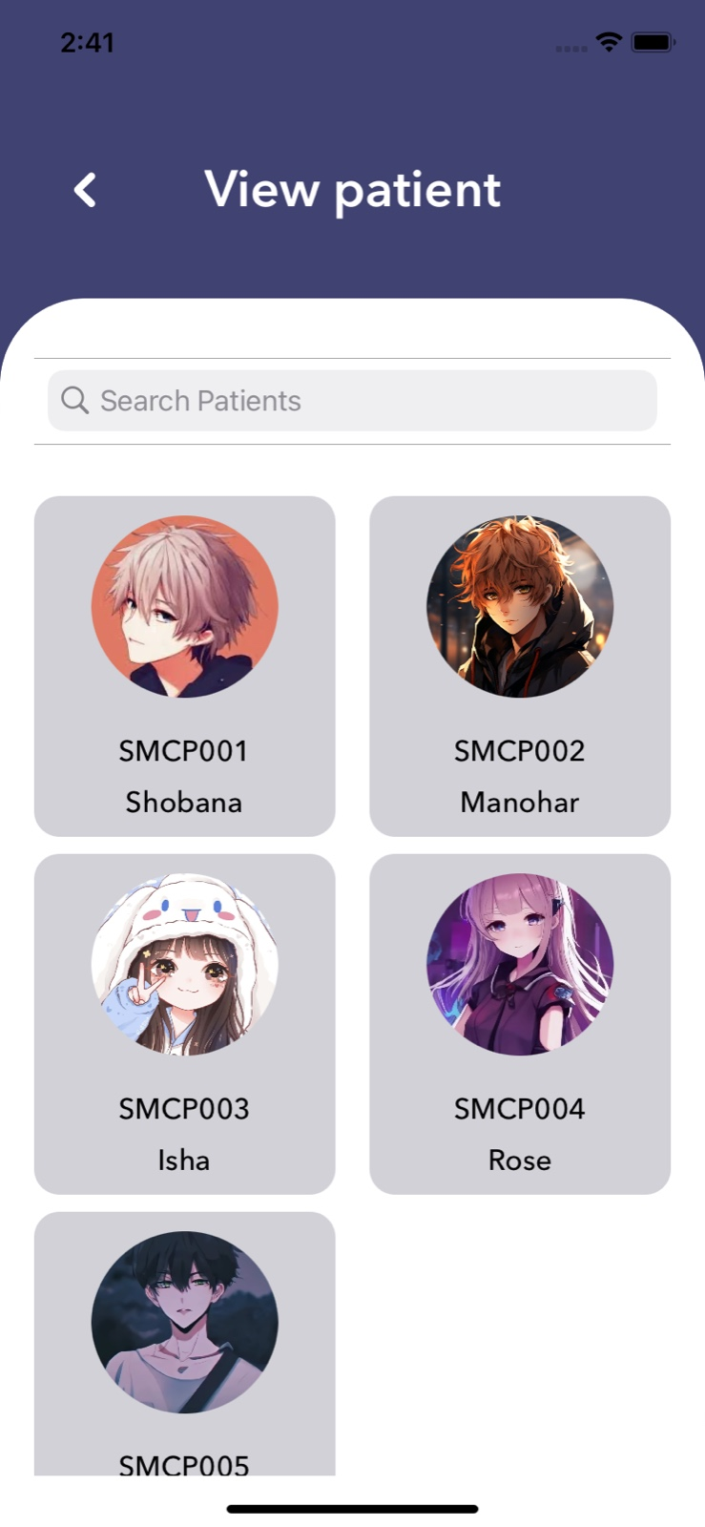
Fig. 1. Displays the patient list screen of the Medication-Reminder application from the doctor login where the doctor can view all the patients. From this screen, the doctor can see the patient’s name, ID, and profile. By tapping on the particular patient details he can access all the details of the patient such as personal details, points, health status, etc.

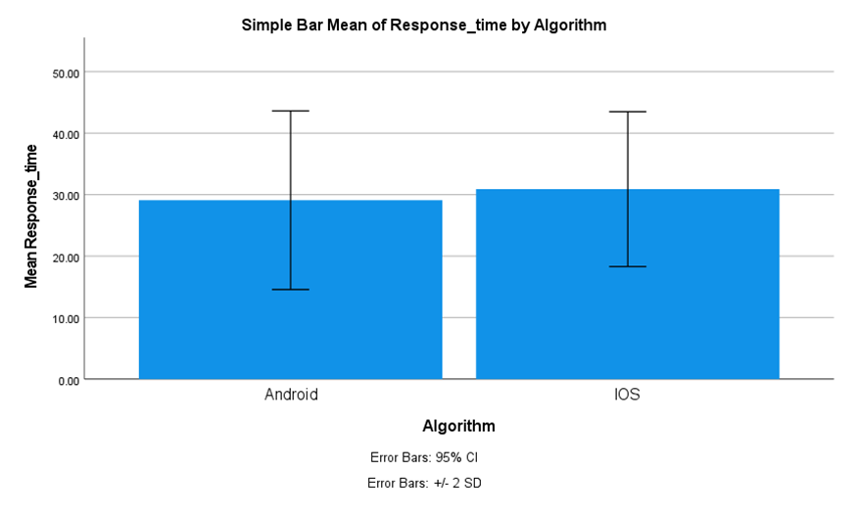
Fig. 2. In comparing the average response times of the two algorithms, the Android algorithm has an average response time of 34.58, whereas the iOS algorithm has an average response time of 29.33. The X-axis represents the iOS vs. Android Development methodology, while the Y-axis indicates the average response time. The error bar is depicted as ±2 standard deviations.

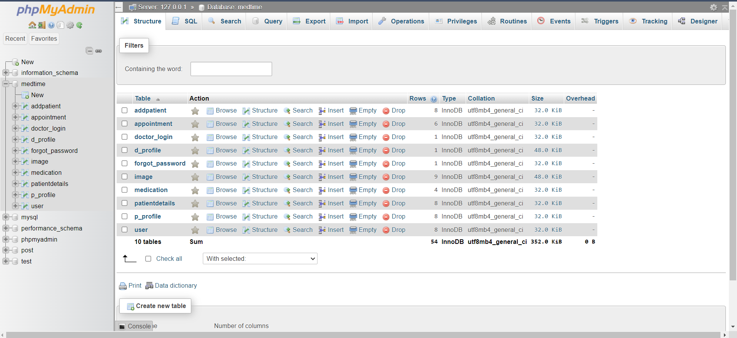
Fig. 3. The figure displays the database tables of the Medication-Reminder application that are used to store data such as doctor details, patient details, tasks, points, videos, task assignments, patient’s health status, etc. This data segregation helps us to understand the procedure of the application easily.

